Notice
On the auspicious occasion of great Nepali festival Vijaya Dashami 2079, Consulate General of Nepal in Chengdu would like to wish all the Nepali people peace, prosperity, and good health.
The Consulate General will remain closed from 3-6 October 2022 for the festival.
The Consulate General will resume its work as usual from 7 October 2022.

通知

值此尼泊尔传统节日德赛节之际，尼泊尔驻成都总领事馆祝所有尼泊尔同胞生活平安、繁荣、健康。
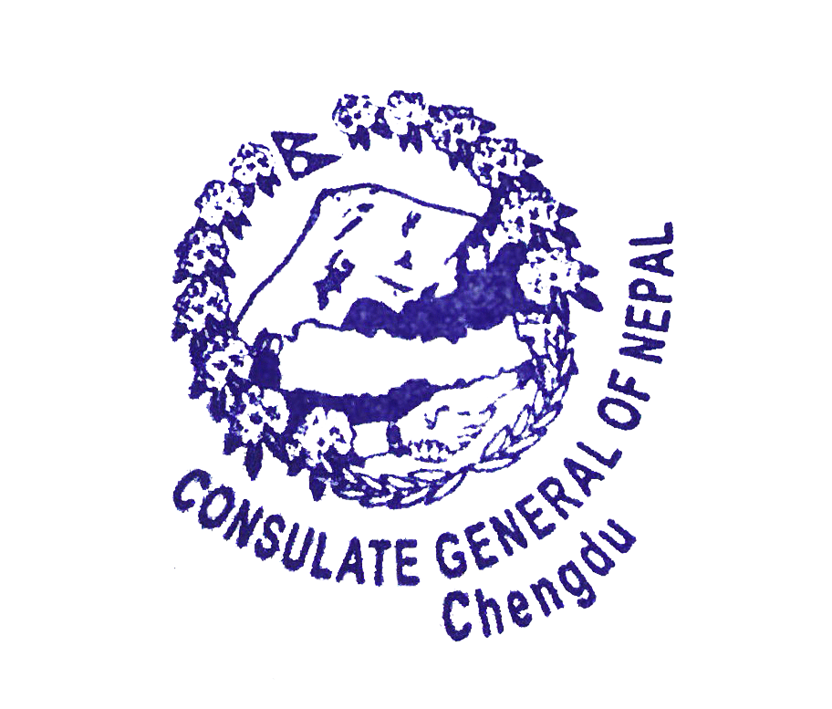
为庆祝德赛节，总领事馆将于2022年10月3日至6日期间闭馆，2022年10月7日起恢复正常办公。

2022-9-27
2022年9月27日

